**Snacktivist Spring 2024 Proso Millet Survey- Results**

Snacktivist shared a Spring 2024 Proso Millet Survey via several farming networks this spring. Our response rate was lower than we had hoped but of the 24 respondents, we gathered some important information. 3 of the respondents were eliminated from the survey results due to being outside of the US.

Here is the geographic distribution of the farmers who responded to the survey:

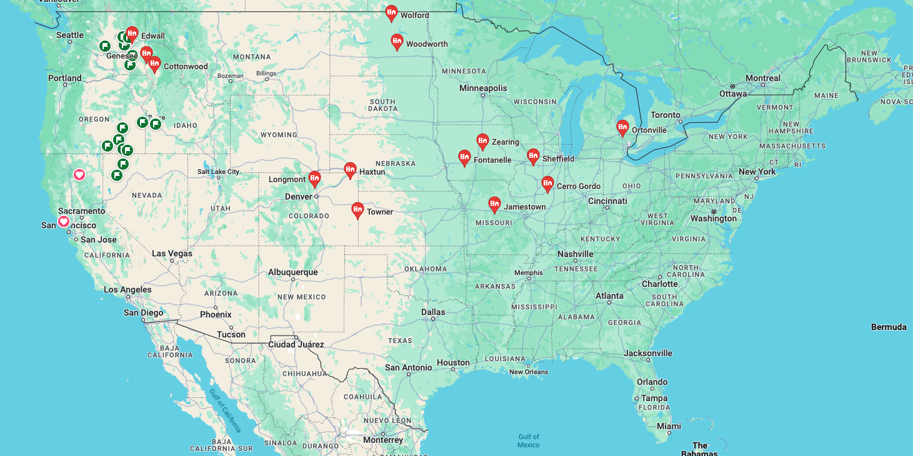

The goals of this initial survey were simply to understand the current availability of Proso Millet, seed variety, desired price, and farm management/3rd party verifications.

Here is what was collected:

47.8% of respondents said they have Proso Millet available with 28,950 bushels available (1,447,500 lbs.). Over half said that the Millet was already cleaned.

The respondents grew:

|  |
| --- |
| Huntsman/240 |
| Kriesel Seed Proso Mix |
| DLG40 |
| Huntsman |
| Horizon |
| Albert Lea Proso |
| Sunup |

The farm management report was diverse:

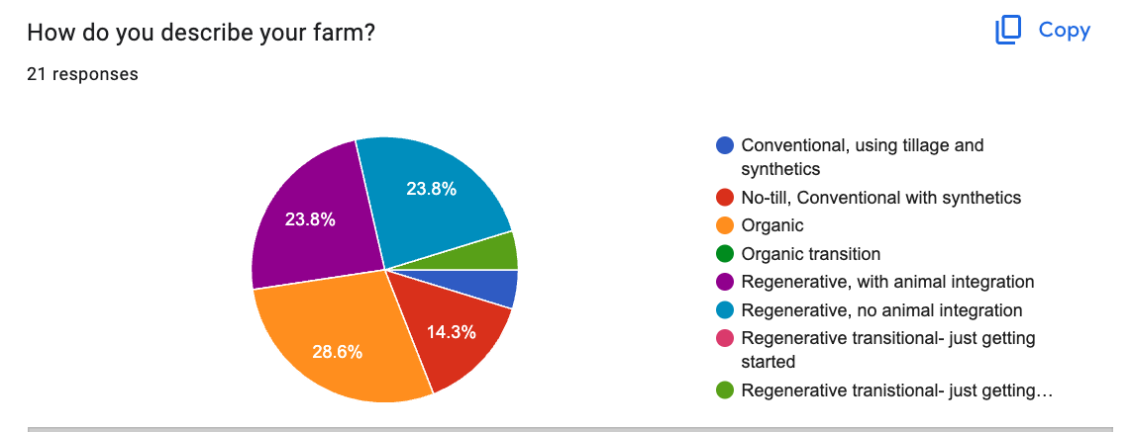

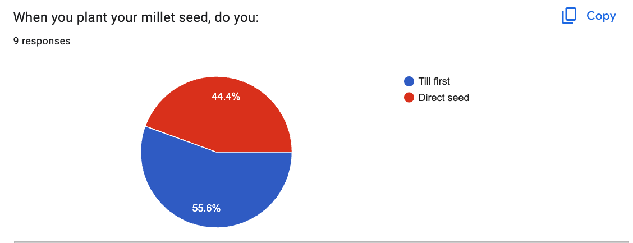

3rd party verification or certifications included:

|  |
| --- |
| Farmed Smart Certification |
| Real organic project |
| USDA Organic |
| EU certified Organic |
| Canada Certified Organic |
| Biodynamic, Demeter |
| Food Alliance Certified |
| Regenerative organic, ROC |
| Farmed Smart Regenerative Certified |
| SCI, Soil Carbon Initiative |
| Regenified |

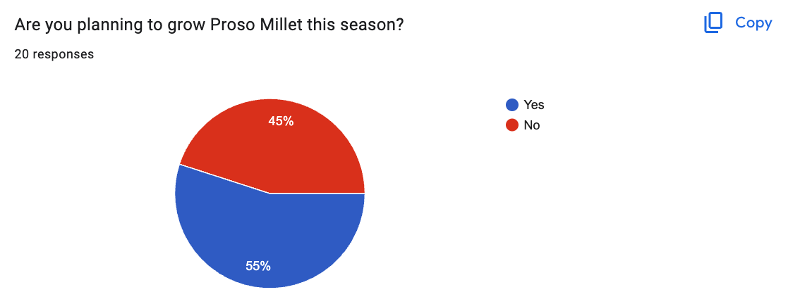

Here are the responses about why or why not they would plant Proso Millet this year:

|  |
| --- |
| Need to find a market for my old crop before I do new crop, Also need a wider swather header if I scale up |
| Need a market |
| Why or why not what??? |
| Know nothing about its agronomics, seed availability, reasonable yield and pricing |
| Helps with weed control |
| All are organically certified and it is part of my normal crop rotation. We can grow high-quality millet in this part of the United States when it comes to test weight and color of seed. |
| We love the rotational benefits! |
| Still sitting on some |
| Excellent rotational crop. It’s a warm season grass, which we don’t grow here on the Palouse |
| We are integrating millet as short-season and warm-season grass into our rotation |
| Lack of Market |
| Need a market |
| It’s a crop that I would like to grow but I haven’t found a ready market in Iowa. If there is a market willing to take organic millet I’d love to put it in the rotation. |
| I thought for grazing I would be better with pearl millet |
| I sold my farm last year. Proso millet is not planned to be planted on it this year. |
| Cause there may be a market for some.... |

5 of the responders said that Millet is a cash crop, 1 said it is a cover crop and 1 said it is a summer fallow alternative.

Other questions/comments we heard from the responders:

* I’m interested in more information.
* Where is the closest delivery point? Who is buying? Who is supplying seed? What is the anticipated yield? Anticipated price?
* How clean of millet are you looking for? Does it need to be Dehulled? Are you looking for monthly deliveries? Are you looking for a delivered in 2000 lb totes we have that available or will it be bulk semi deliveries? I should have around 50,000 bushel this year of millet and have a few fellow growers of organic millet and am able to produce 100-200,000 bushel a year regularly if needed as well.
* Can it be grown in my area? Always interested in another crop for rotations.
* Was a complete loss, emerged well but every armyworm in the state showed up for breakfast and mowed it down, Years ago I farmed in S/E Minnesota and grew it with no problem. Looking for a food grade variety of proso or other breed of millet that will grow in central Missouri as a good food/feed grain catch crop on in rotation. Any Ideas?
* I am interested in growing millet but I am not aware of market opportunities. Would be interested to know more.
* I am just looking for alternative crops.
* What you need to do is learn that millet is a catch crop that will never have a lot more acres grown than are currently planted. Millet is a low-input crop for farmers in general. Good luck trying to find new markets. You have a problem in doing so. A farmer wants a premium if you expect him to grow more acres/bushels but the end user does not want to pay extra to try to create more production. Also, millet production is highly variable and because of this it is hard to guarantee anyone a consistent supply year after year It is the old chicken and egg scenario. It is grown over a fairly small geographic area because it is just a niche crop. Will never replace corn, bean, and wheat acres to any amount.