|  |  |
| --- | --- |
| Nate Blum  Chief Executive Officer  Sorghum United  2500 West Cardwell Road Lincoln, NE 68523  +1 402 802 1850  sorghumunited@gmail.com  www.sorghumunited.com | Supports the |

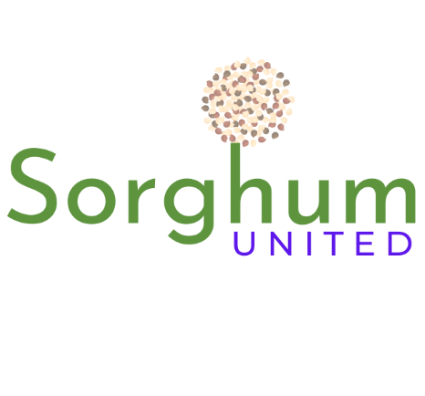

**For Immediate Release:**

**Monday, May 22, 2023**

2023 NORTH AMERICAN SORGHUM AND MILLETS CULINARY EXPERIENCE IN GRAND ISLAND NEBRASKA RESCHEDULED FOR SEPTEMBER 25 AND 26

**Lincoln:** Sorghum United will host the 2023 North American Sorghum and Millets Culinary Experience September 25th and 26th. The event will be held at Raising Nebraska, located at Fonner Park. The Experience is intentionally designed to provide cooking demonstrations and presentations regarding the nutrition and environmental impacts of small ancient grains for the benefit of chefs, dietitians, nutritionists, and physicians. However, the event is also free and open to the public.

“Innumerable scientific studies regarding the positive impacts of including sorghum and millets in human diets have been published globally in the past decade. As a result, more and more culinary professionals have begun incorporating these climate-smart ancient grains in their formulations and recipes,” stated Sorghum United Chief Executive Officer, Nate Blum. “Raising Nebraska will be an ideal location at which to showcase the valuable health benefits of sorghum and millets as components of the next generation of consumer food products.”

This event will be held in partnership with the North American Millets Alliance (NAMA) and in conjunction with the United Nations (UN) “International Year of Millets”. Registration is free and can be found at: eventbright.com, Keyword “SorghumUnited”.

Chefs and researchers seeking to register to present may do so at: signupgenius.com, Keyword “sorghumunited@gmail.com”.

*Sorghum United is an international non-governmental organization working for consumer and producer education, markets development, entrepreneurial empowerment and global food security in the sorghum and millets space*